**LAB 4**

**Q1) Do the same above program using 16b unsigned variable**.

**(Example 2)**

Program:

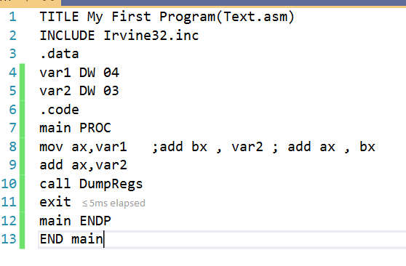

;K190207 Sara Jamal

Output:

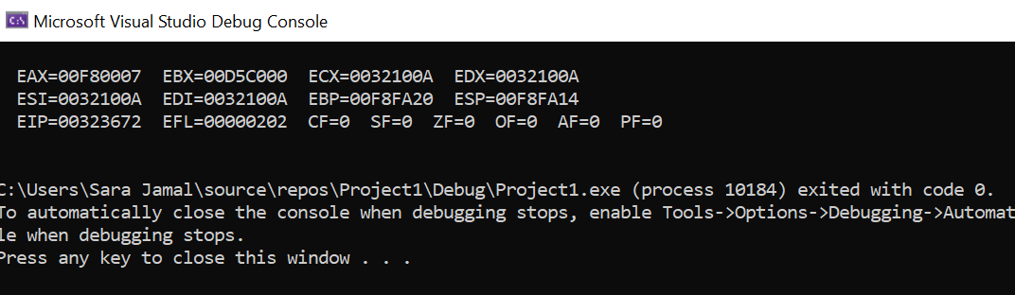

**Q2) Implement the above program using 16bit unsigned variable. (Example 3)**

Program:

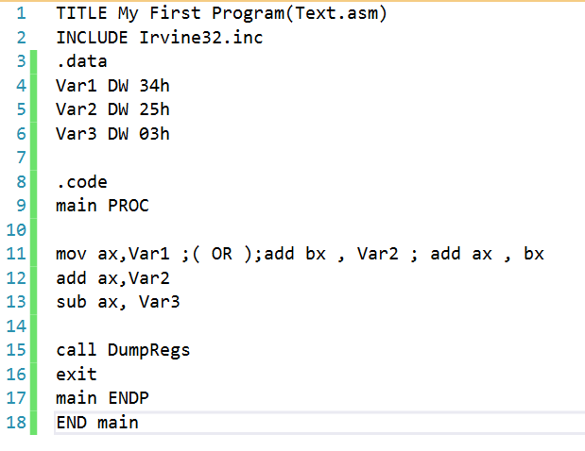

;K190207 Sara Jamal

Output:

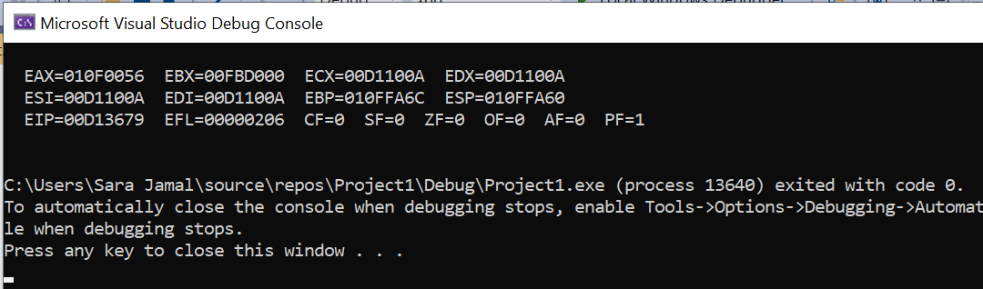

**Q3) Do the same above program by using 8bit unsigned variable. (Example 4)**

Program:

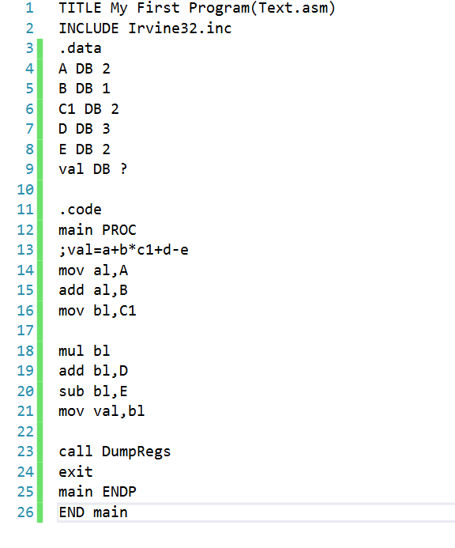

;K190207 Sara Jamal

Output:

